https://onedrive.live.com/view.aspx?resid=DC499B8DE8964F55!5489&ithint=file%2cpptx&authkey=!AlSJ_jziRIacoNU
CHECKLIST
Report
- Turnitin < 5%
Presentation
- 20 minutes presentation + 5 minutes for questions
- Everyone presents
Other
- PRINT presentation slides
- PRINT report
- Send zipped CODE (compress it)

Be logged in two emails, bob and jessica pwd123456

4 mins for demo/each 230 powerpoint

- For the software presentation and demo, please focus on the following points:
(a) The problem to be solved and motivations (Mahrs) - intro
(b) The main functional requirements (Stephen)
- Show list
- Show use case diagram here
(c) The software architecture (Mathew)
- Show architectural design diagram here
(d) The design patterns. Explain precisely their usability for your specific application (show their detailed/customized class diagram). (Stephen + Matthew)
- Class diagrams
(e) Deployment (Stephen)
(f) The list of software development tools used to build your application (Mahrs)

Demo
Non-registered requirements (Mahrs)
- Show info pages
- Search and filter
- Listing details
  - Show pictures

Registered requirements (Mathew)
- Login
- Create a post
- Edit profile, edit post
- Mark unavailable
- Admin authentication
  - Show approve, have inapp. listing to delete
  - Show that the listing is now on page

(Stephen)
- Login 2nd account -> click subscribe, send request form
- Login 1st account -> mark available
- Show emails of 1st account for request form
- Show emails of 2nd account for subscribe

CS 476 PROJECT REPORT
Title
Regina’s Recreational Rentables
Group Members
Stephen Lerminiaux (lerminis@uregina.ca)
Mahrukh Aslam (mav499@uregina.ca)
Mathew Dorish (mrd085@uregina.ca)

Problem definition. Provide the type of problems you are solving and the motivations of your project.
Problem Definition
We have been contacted by a company that wants us to develop a website that will allow people to get into contact with renters of sports equipment in Regina. Renters will be able to create listings, upload images of equipment, set prices and indicate listing availability. The listing must be approved by the admins before it is uploaded to the website. Users looking to rent will be able to browse listings and send a request form to the renter for the item they are interested in. This form will be sent to the renter through email allowing communication between the renter and the person looking to rent. There will be three types of users: non-registered users, registered users and the admin. Non-registered users will be able to search and browse for listings but will require registration to create a listing and contact listers. The admin will have the ability to approve and disapprove listings, edit listings, and delete listings.
We have chosen to undertake this project because we wanted to concentrate on a project with a local scope since Regina lacks applications that focus on renting sports equipment. We are building the website with the idea that the users will be individuals wanting to rent out their sports equipment and small businesses that may not have a dedicated platform to advertise their rentable equipment. Furthermore, other websites aimed at renting sports equipment lack essential features such as a subscription tool, administrator approval and filtering options that we are incorporating in our website.
We have decided to use the Django web framework for this project. It is a python-based framework that uses a Model-View-Template architectural pattern. For the database, we have chosen PostgreSQL as it is the database management system best supported by Django. On the front-end we will be using Bootstrap, HTML, and CSS. We have chosen these applications to develop our software because we are hoping to gain new knowledge and overcome challenges as a team as all of us are new to Python, Django and PostgreSQL. We aim to familiarize ourselves with these tools, learn different ways to implement the requirements and get a better understanding of the framework.
There are a few collaboration tools we will use to communicate with each other and manage the project. We will be using GitHub to host our project, in which we will create a repository that will allow us to push changes to it and pull from it, thus allowing for version control and efficient collaboration. We will be using a shared document on Google Docs to post tutorials, links and other resources related to the project. We will also be using Google Docs to create, plan and write the report. We will be using WhatsApp to arrange meetings, discuss any issues and keep in contact with each other.
Economic feasibility study document (2 pages). Clearly show if you are developing a new system, extending or improving existing ones (include references to the current solutions). What are the benefits of your application when compared to existing solutions?
FEASIBILITY DOCUMENT
Regina’s Recreational Rentables is improving and simplifying existing solutions. We will be comparing our website with the applications below:
- Peer Renters
Source: http://www.peerrenters.com/
Description: Peer Renters is a company based in Vancouver, BC with the aim to support a non-wasteful lifestyle by providing people with a platform to rent out used items.
2. Spinlister
Source: https://www.spinlister.com/
Description: Spinlister is a company based in Santa Monica, California. Their website allows users to rent out outdoor sporting gear, such as bikes and snowboards.
Here are the benefits of our solution compared to Peer Renters and Spinlister.
 | Regina’s Recreational Rentables | Peer Renters | Spinlister
User interface | - Simple and easy to use interface  - Grid-based organization  - Consistency among layout and style of pages  - Minimalistic design  - Core features easy to identify | - Inconsistent design  - Dull and unpleasant color scheme  - Several pictures overlap text  - Core tasks can not be readily identified  - Broken links on the website  - Slow and unresponsive  - Confusing navigation bar on search page | - Complex user interface  - Map feature and listed items adds clutter and complexity
Ease of Use | - Users are able to browse listings without making an account  - Listings can contain multiple items. For example: several sizes of skates in a single listing | - Application is only available to users with an iPhone  - Unable to list multiple item in one listing | - Unable to list multiple items in one listing
Products | - Users are able to rent out any recreational sporting equipment | - No limitations on the items available to rent | - Limited to bikes, surfing, and snow equipment
Efficiency | - Simply connects users to renters, fill out a form and an email gets sent to the renter  - Subscribe to receive email when a listing becomes available | - Unable to view listings without downloading the application and creating an account  - Listing map difficult to use and navigate | - Requires navigating through a map to find search results
Robustness | - Handles user input errors  - Validation for registration, login and creating a listing | - Passwords are emailed after registration in plaintext posing a security risk  - Poster address shown to viewers by default  - PHP errors meant for developers visible to users | - Can enter any symbols in name field of sign up page  - Faulty error message while creating account with an already in use email
Location | - Local to Regina | - Worldwide, however users are only able to browse items in their location | - Worldwide
Fees | - No fee, renters get 100% of the charged rate | - 10% fee | - 17.5% fee  - Renters are covered up to $10,000 if their item is damaged or stolen
Payment | - Does not require credit card, can pay in person | - - Required that all payments be made via credit card using the system | - - Required that all payments be made via credit card using the system

From the above comparisons, the main benefits of our solution are its simplicity and elegant design. Being local to Regina allows for quicker searches and a niche product for the population of Regina. No transactions are required through our website, as its main purpose is to connect listers with those wanting to rent equipment via email. The payments will be the responsibility of those involved in the transaction. Furthermore, our solution requires no costs to the users. In addition, users can browse listings without having to create an account, and are able to do so on their computer, or through their phones, without having to download an application.

Functional requirements list (only the ones that you have implemented) for each user type. Explain each requirement briefly.
Functional Requirements
Non-registered Users
- Register: Must be able to create an account
- View Info Pages: Must be able to View Meet The Team, Help & F.A.Q., and Terms & Agreements pages
- Search Listings By Name: Must be able to search listings by keyword(s)
- View All Listings: Must be able to view all listings related to the keyword(s) entered
- Filter Listings: Must be able to Filter Listings By Location (e.g. south end), Filter By Availability, and Filter By Daily Rate
- View Listing Details: Must be able to view the details of a specific listing and additional images

Registered Users
- Registered users inherit all of the functional requirements of a non-registered user (except Register)
- Send Request Form: Must be able to contact the owner of the listing. This message must then be sent directly to the owner’s email (requires login)
- Subscribe To Listing: Must be able to subscribe to a listing to get an email notification for when the item becomes available, and the listing’s owner should receive an email response that confirms which subscribers were notified (requires login)
- Login: Must be able to login to registered account
- Logout: Must be able to log out of registered account (requires login)
- Edit Profile: Must be able to update email, username, password, etc. (requires login)
- Create Listing: Must be able to create a new listing with relevant fields (requires login)
- Manage Created Listings: Must be able to manage their own listings by being able to Delete Listing, Edit Listing, Set Listing Availability (requires login)

Admins
- Approve Listing: Must be able to approve new and updated listings
- Delete Any Listing: Must be able to delete any user’s listings
- Delete Any User: Must be able to delete users which in turn deletes their listings

Use case diagrams with all the use cases and actors. Describe in detail three use cases (the most complex ones) with activity diagrams.
USE CASE DIAGRAMS
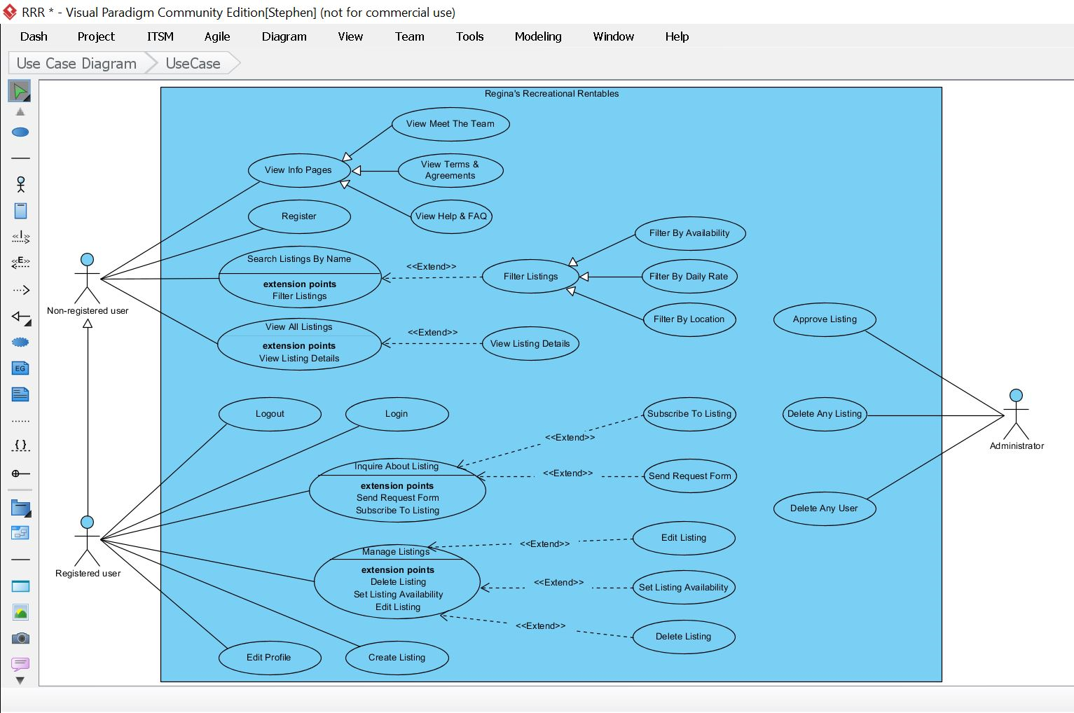
Three most complex use case
- Manage listings - Users who are logged in are able to edit their listings, set availability of listings and delete listings
- Approve listings - Admins are able to accept or reject new listings, and allow listings to be viewed on the listing page
- Filter listing - All users are able to filter by today’s availability, daily rates, and zone in city

1. Activity diagram for Manage Listings
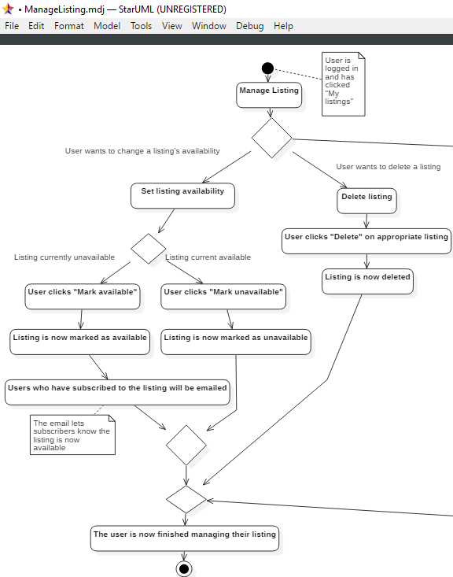

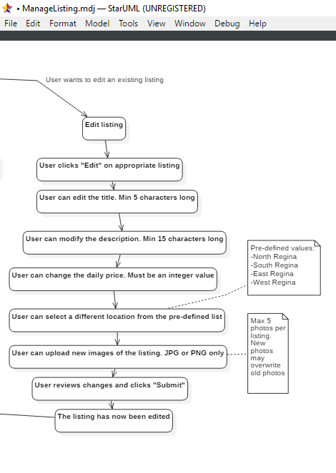

2. Activity diagram for Approve Listing
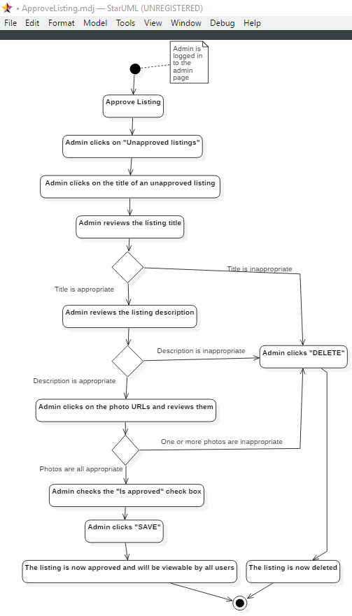

3. Activity Diagram for Filter Listings
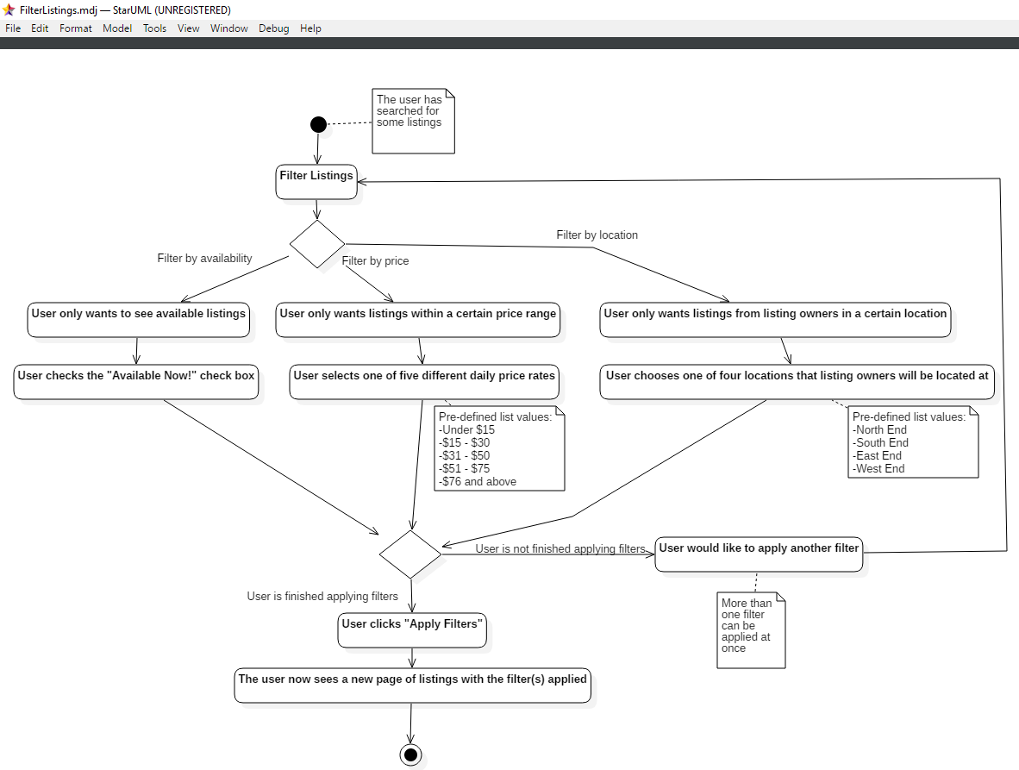

Software Qualities
The system must correctly solve the problem. All of the functional requirements defined must be met. Also, all algorithms used within the system should always produce the correct results based on the input and what they have been designed to accomplish. Having the system adhere to all of the defined functional requirements ensures that the system has been designed and developed correctly, correctly satisfying the customer needs. Having all of the algorithms produce correct output is also very important. Suppose a user searches for an item to rent, and once the system displays a list of results relating to the user’s query, the user wants to sort the listings. If they want to sort the listings by price, but the sorted items do not all fall within the user-specified price range, this will frustrate the user since the system does not work as intended.
The system must be time efficient. User actions should be processed quickly, and all algorithms used should not be overly complex. Being time efficient is very important for keeping the users satisfied with the system. Consider the scenario where a user is interested in using the system, so they decide to create an account. Once they attempt to create their account, however, the system is stuck processing their information for an extended period of time. Many users would not be willing to wait long for the process to finish, and eventually they would close the page and never come back. Without the system being time efficient, it would not gain as many registered users as possible. Being time efficient also decreases the strain on server(s) that the system will be deployed to. Fewer concurrent users will be able to use the system if it is not time efficient, because each user will use a larger portion of the server resources, compared to a time efficient system.
The system must be robust. This means that the system must be able to handle malicious and erroneous input from its users. It should not crash when the user inputs something different than what they have been expected to input. It is essential that the system be robust. Being able to handle malicious user input ensures that users will not be able to damage the system or its database. For example, consider the scenario where a user searches for a specific item to rent. Their input is queried in the database. The system must sanitize the input, to prevent any possible database attacks. Without sanitizing the input, entire tables could be deleted from the database, which would destroy the system. Similarly, it is important that the system handle erroneous user input. This will prevent the system from crashing when a user does something unintended, such as trying to upload a video to their listing instead of an image.
The system must be user friendly. Users must be able to quickly learn, and remember how to use the system. All of the system’s features must be easy to locate, learn, and use. The system must be aesthetically pleasing, responsive, simple, and intuitive. This allows for users to easily navigate the website on multiple platforms. A system that is not user friendly will confuse its users, and may cause a number of users to quit using the system in favour of a different system, that is more user friendly. Suppose a user has found an item to rent and is wanting to send a message to the owner of the item. The user will get frustrated, and possibly even give up, if the message form is hard to find in the page. This would then cause the owner of the item to lose out on making some money from not being able to rent out their item to the user who could not find the email form.
Logical software architecture. Decide which architectural style you will use for your application. Explain in detail why did you choose this style. NOTE: NEED TO INCLUDE DIAGRAM
Logical Software Architecture
The logical software architecture chosen for the application was the Model-View-Template architecture, or MVT. MVT is how the chosen framework for the project, Django, implements the Model-View-Controller architecture. The views in our application work as standard controllers (what data is displayed), while the templates are Django’s version of views (how the data is displayed). The MVT architecture was chosen because it allows team members to work on independent parts of the project concurrently, without having to worry about affecting the work of other team members. This was crucial for us because of the project’s time limit, as it meant we didn’t have to wait on one another before we could begin working on our respective parts. MVT also offers high scalability, safety and security, and it is a reliable and trusted architectural style so we knew it would work well for us.
One of Django’s official design philosophies for their MVT architectural style is loose coupling and high cohesion. There is loose coupling because the models, views, and templates only know about themselves. Templates know nothing about how the data being displayed to the user is obtained from the model by the view, for example. There exists tight cohesion because classes are designed for a very specific use. Within Django there exists sub-apps. Each sub-app consists of its own models, views, and templates. For example, two sub-apps that exist within our application are listings and accounts. Listings has its own models, views, and templates for everything that deals with the listings, such as the model that deals with the listings table in the database. The accounts sub-app deals with everything relating to user accounts, such as the login and register pages. Splitting the code up into these sub-apps provides very tight cohesion, and also provides high maintainability.
Another benefit of MVT is its scalability. Creating new templates for the app was very easy. While we were developing the app, we found that there were some changes that we could make to our original design specifications that would make the application better. For example, we wanted to add a page where users could edit their account details. Creating the template for this page was very simple, because of how the MVT architecture works. The three components of MVT also offer high safety and security. It would be dangerous if one user could access the edit profile page of another user. However, the accounts view only allows users to view the template of their own edit account page. The other views also provide similar security, preventing users from accessing data that isn’t theirs.
While a different architectural style like the 3-layer architecture might be more easy to use, the MVT architecture provides many additional benefits that the 3-layer does not. With MVT, Django handles the “controller”, the views will notify the templates when a model is updated, and they will update themselves to display the updated data. The MVT architecture also allows for code reuse, which was very important considering the relatively short time period of this project. All of these reasons made the Model-View-Template architecture the perfect choice for our application.
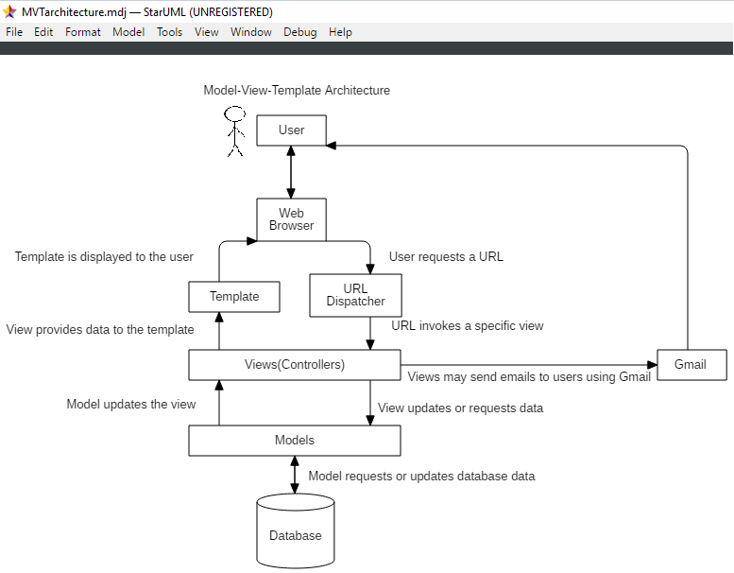
This diagram is based on the following image of the Django architecture: https://hpctardis.readthedocs.io/en/latest/_images/DjangoArchitecture-JeffCroft.png.
To better understand how the Model-View-Template architectural style works, consider the follow scenario: In Django, URLs are mapped to a specific function in one of the views (which act as controllers in MVT). So whenever a valid URL is entered, a specific function will be invoked. If a user were to enter the URL to one of their listings, the listing function will be invoked from within the listings view. This is because the URLs of specific listings are mapped to the listing function in the listings views. This is done in the urls.py file of the listings subfolder. The listing function then requests data from the Listing model. The Listing model obtains the relevant information directly from the database, and provides it to the listing function. The listing function then passes the specific listing data to the listing template, where it is displayed to the user.
While viewing a specific listing, the user can also send the owner of the listing an email. The same listing function is invoked from the listings view, which then sends the message directly to the owner of the listing using Gmail.

Design patterns. Explain in detail why did you select these patterns. Give the complete class diagram for each selected pattern. You should also provide the algorithms corresponding to the pattern’s main methods.
Factory Method Design Pattern
RRRentables features three different types of messages that will be displayed to the users after they perform specific actions. The types of messages include error messages, which are displayed when something goes wrong. For example, an error message is displayed to the user when the user attempts to update their username to a name that is already in use. There are also success messages, which are displayed to the user when they perform a successful action. One instance where a user would see a success message would be when they update their username to one that isn’t currently in use. Finally there are warning messages. These are displayed when the user marks one of their listings as unavailable. All three message types have a unique styling, and the messages they produce are all different. The factory method allows a Creator class to instantiate the respective ConcreteMessage class which then displays the appropriate message to the user. Because of how these messages work, the factory method was a suitable choice to implement in the application.

Factory Method Algorithm
In our application, whenever a message is to be displayed to the user, a ConcreteCreator object is instantiated. As this happens, the Creator class automatically initializes three values, which include request, context, and message. Request is the http request made by the user, and is required by Django. The context determines the type of message to display to the user, and will either be “success”, “error”, or “warning”. Message is the actual message that the user will see and read to understand what just happened. ConcreteCreator then initializes and returns one of the three ConcreteMessage classes, depending on the value of context. The application then calls the ConcreteMessage’s display function, which displays the appropriate message to the user.

Found below is how the create function in the ConcreteCreator class is implemented, followed by the display function found in the three ConcreteMessage classes. Following the descriptions is the Factory method class diagram. The diagram is based on the Factory method class diagram found in the book Design Patterns: Elements of Reusable Object-Oriented Software.

** describe only one or two methods in detail, dont list classes

Public Message create(request, context, message):
#ConcreteCreator chooses the type of Message class to return
If context == “success”
Return success message object
Else if context == “error”
Return error message object
Else if context == “warning”
Return warning message object

Public void display(request, message):
#This function makes use of Django’s built in messages framework
messages.messageType(request, message)
#Where messageType == “success” or “error” or “warning”
#The message parameter is the text that is displayed to the user

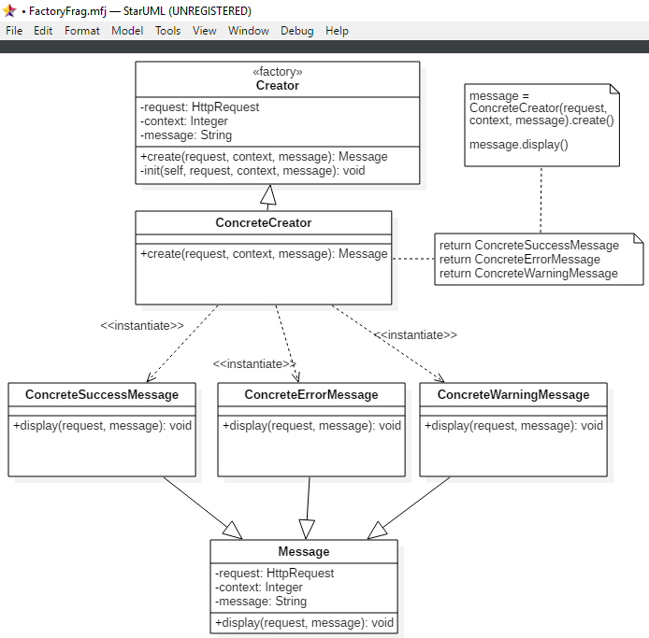

Observer Design Pattern
The observer pattern was selected based on the client’s requirement that users “must be able to subscribe to a listing to get an email notification for when the item becomes available”. The solution of this requirement was seen as a simple variation of the publish-subscribe pattern. Regina’s Recreational Rentables uses this pattern where a concrete subject is a Listing object and a concrete observer is a User object. While there may be a simpler pattern that can perform the simple action of emailing subscribers, we can use the Observer pattern to add multiple concrete observers in the future if desired. An example could be a logging system that records subscriber actions, how many times an item is rented out, etc.

Observer Design Pattern Algorithm
This application implements the Observer pattern with the push method, as it allows for loose coupling and we have prior knowledge that all observers require the same data. The Listing objects act as concrete subjects while the User objects act as concrete observers (via proxy). A User can ‘register’ to a Listing while viewing its details which adds that User’s email to the subscribers array. When the Listing’s owner changes the Listing’s state from is_available=False to is_availble=True, an email message will ‘notify’ all subscribers that that Listing has just become available for rent. The ‘update’ method is called in the ‘notify’ method, which sends confirmation emails to the owner of the listing for every subscriber that was successfully notified. The user can also ‘remove’ itself from the subscribers array if it no longer wants to receive email notifications.

Found below is pseudocode for the ‘notify’ and ‘update’ methods.
Public void notify(self):
#Notifies the observers (Users) by email when a listing becomes available
for sub in self.subscribers:
ConcreteObserver.objects.get(email=sub).update(self)
to_email.append(sub)
send_mail(to_email)

Public void update(self, subject):
#For each subscriber, sends an email to the listing’s owner to confirm he/she was successfully updated about the listing now being made available.
send_mail(to_email)

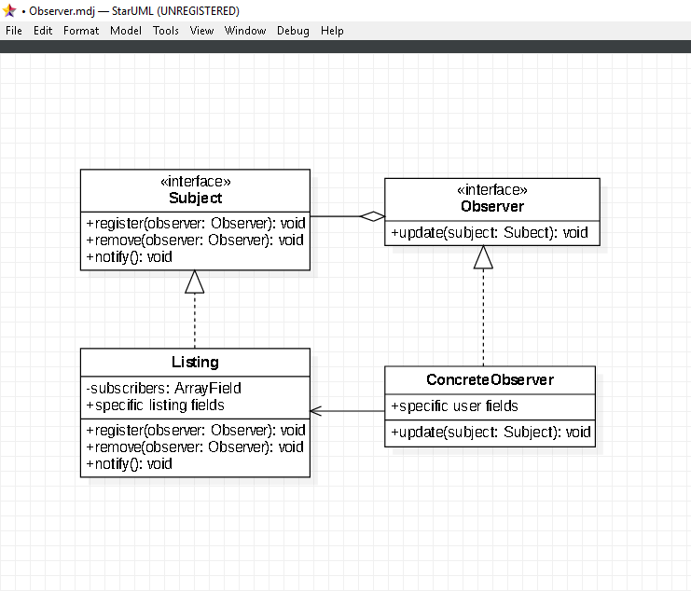

Class diagrams by incorporating the design patterns. For each class,you should provide the data types of the attributes and the function prototype
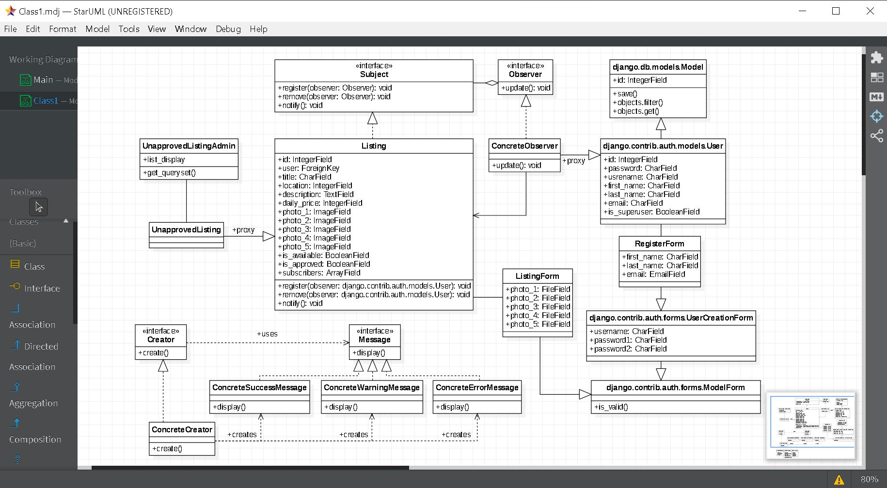

Component diagram regarding the organization of the source code.
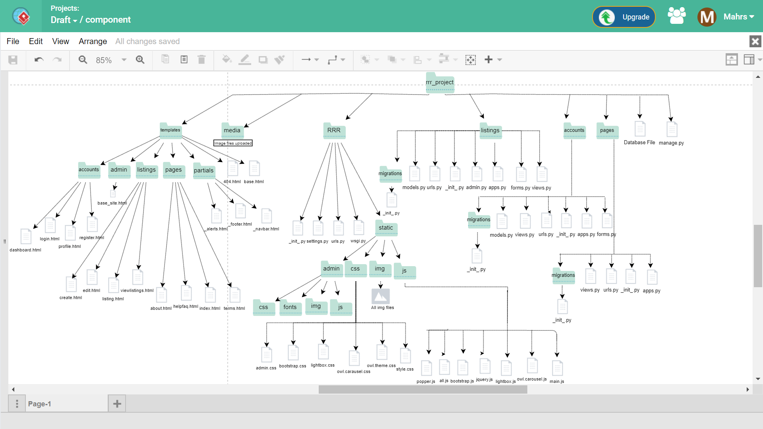

Deployment diagram regarding the hardware configuration of the source code. Indicate the supported Web browsers, the application/Web servers and the data base solution.
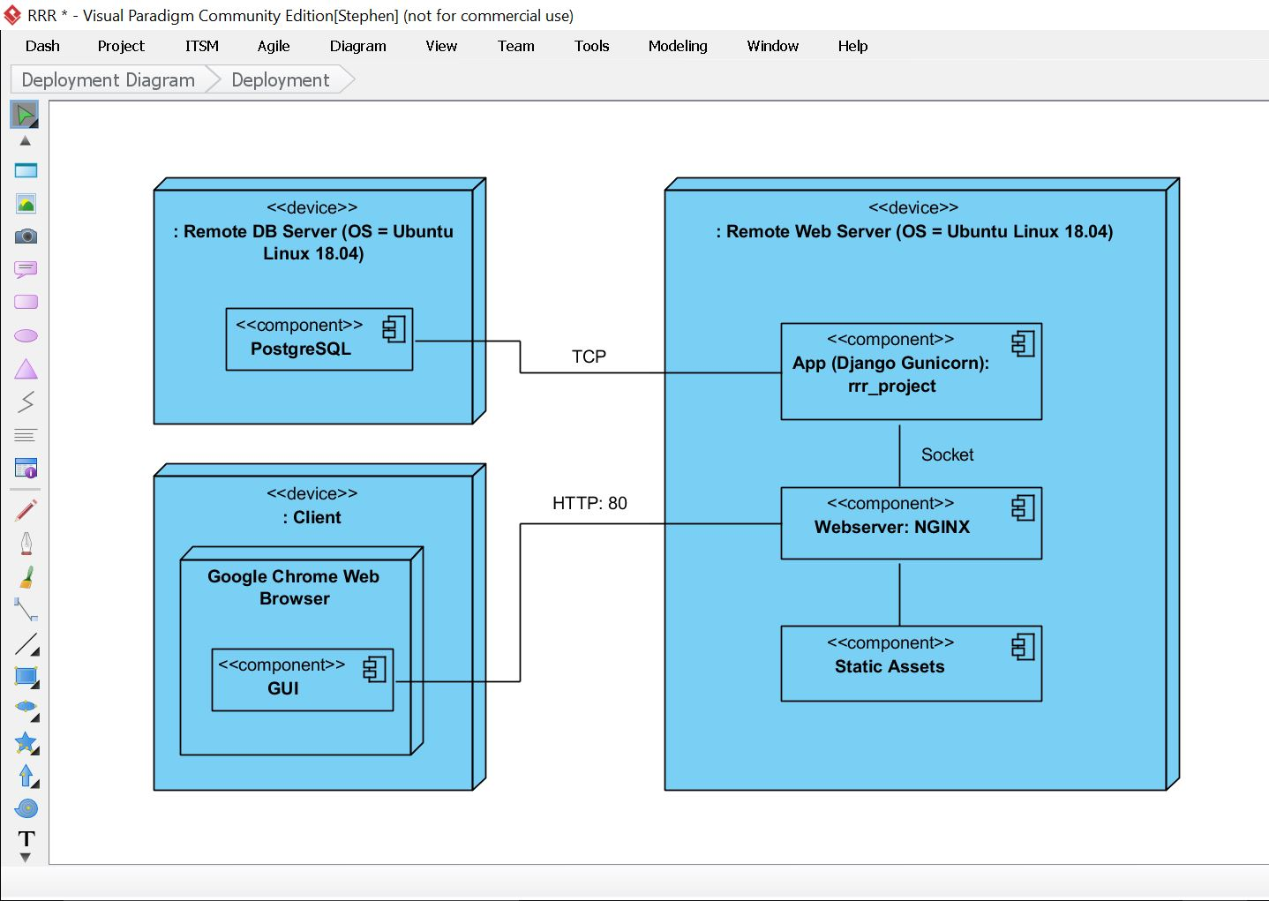

List the classes and functions that you have implemented.
Class / Function Name | Description
RegisterForm | Class for extending the built in UserCreationForm to get user’s email and full name in sign up
register() | Function to register for account using RegisterForm
dashboard() | Function that allows a logged in user to edit their profile
UnapprovedListing | Class that inherits values of Listing
UnapprovedListingAdmin | Class that displays all unapproved listings to admin
ListingForm | Class that defines a custom Form to manipulate Listing Data
Creator | Class that declares the factory design pattern and returns an object of type Message
Creator.create() | Abstract method to be overwritten, creates a message object based on the type
ConcreteCreator | Class that creates an object for Creator class
Message | Abstract class for all three Message classes
Message.display() | Abstract method to be overwritten, displays the message to the screen
ConcreteSuccessMessage | Class to display success message
ConcreteErrorMessage | Class to display error message
ConcreteWarningMessage | Class to display warning message
Subject | Class that provides Subject interface (observer pattern)
Subject.register() | Abstract method, registers an observer to subscribers
Subject.remove() | Abstract method, removes an observer from subscribers
Subject.notify() | Abstract method, notifies the observers that Subject data has changed
Observer | Class that provides Observer interface (observer pattern)
Observer.update() | Abstract method, called from each observer when notify() runs.
ConcreteObserver | Proxy class to Django’s built-in User model, acts as a concrete observer for the observer pattern, implements Observer interface
Listing | Class that defines a Listing model, also acts as a concrete subject in the observer pattern, implements Subject interface
listings() | Function that renders the viewlistings.html template, and a creates a context for filtering and displaying listings from the database
listing() | Function that renders the listing.html template, takes in a specific listing’s id, creates a context to display that listing
create() | Function that renders the create.html template, and uses a form to create a new listing
edit() | Function that renders the edit.html template, takes in the specific listing’s id, creates a context to update the listing in the database
delete() | Function that takes in a listing’s id, deletes it from the database, and redirects the user to the dashboard
index() | Function that renders the index.html template
about() | Function that renders the about.html template
helpfaq() | Function that renders the helpfaq.html template
terms() | Function that renders the terms.html template
Screenshots of all the tables of the system data.
User Table
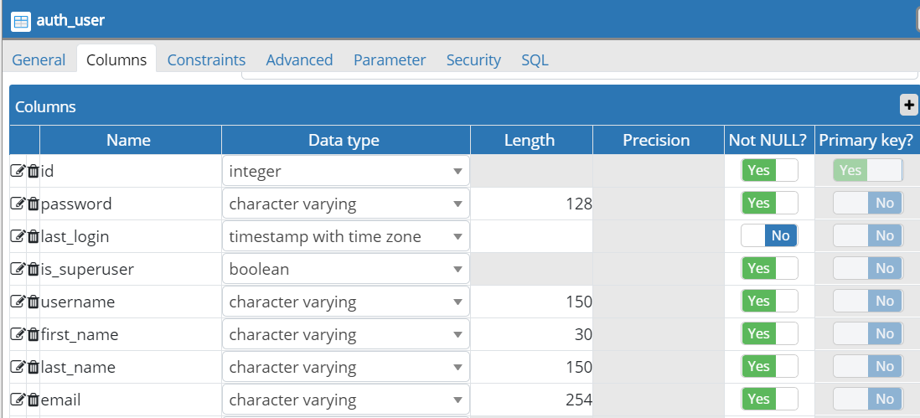
Listing Table
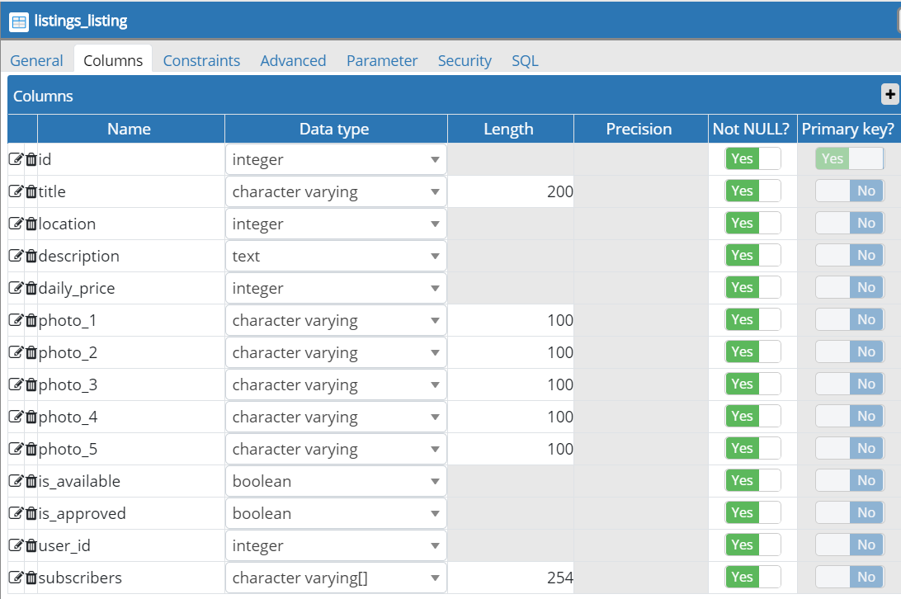

Programming languages
- Python 3.7
- HTML5 (Hypertext Markup Language)
- CSS3 (Cascading style sheets
- Javascript
- SQL (Structured Query Language)

Reused algorithms and programs. List their exact sources.
- jQuery (https://code.jquery.com/jquery-3.3.1.min.js)
- Font Awesome (https://use.fontawesome.com/releases/v5.0.8/css/all.css)
- Bootstrap (https://maxcdn.bootstrapcdn.com/bootstrap/4.3.1/css/bootstrap.min.css)
  - Homepage template (https://www.youtube.com/watch?v=9cKsq14Kfsw)
- Lightbox (https://lokeshdhakar.com/projects/lightbox2/)
- Owl Carousel (https://owlcarousel2.github.io/OwlCarousel2/)
- Poppins Google Font (https://fonts.googleapis.com/css?family=Poppins:400,500,700)
- Popper.js (https://popper.js.org/)
- All.js (https://github.com/learnsomuch/all.js/blob/master/all.js)

Software tools and environments. Indicate which software parts are using which tools. In addition, provide the benefits of such tools for your specific application.
Used for | Software Tool  /Environment | Description | Benefits
Coding | Django | Python-based web framework that was used for development of the website | - Great documentation assisted in ease of learning Django  - Built in Admin models for admin functions and built in User forms for login and registration  - Migrations that automate changes to PostgreSQL database tables
Coding | Virtual Environment (virtualenv) | A python tool to create isolated environments. | - Allows for the installation of python libraries in the virtual environment instead of installing them globally  - Easily keep track of all dependencies for our project
Coding | Visual Studio Code | Source code editor that was used to manage the project and assisted in the writing, compilation and editing of code. It served as a terminal, editor, and debugger for our project. | - Embedded Git control eased in pushing and pulling from repository  - Python Template extension used for Python syntax  - Django Template and Django Snippets extensions used for writing Django code
Communication | WhatsApp Messenger | Messaging application that was used for communication within our team. | - Allowed for real-time communication to arrange team meetings and tackle issues  - Allowed for quick image sharing to send screenshots of errors  - Has access for phone and web
File & Project Management | Google Drive | Used for file storage and sharing of the Google Doc document, diagrams and links. | - Can quickly upload files and share with each other  - Has access for phone and web
 | Google Docs | Used to compose documents with each other at the same time. | - Used in team meetings to view the same document on our own devices.  - Used for collaboration, editing and viewing documents
 | GitHub | Used to host our project, in which we created a repository that allowed us to push changes to it and pull from it | - Allowed for version control which allowed us to track changes  - Provided efficient collaboration  - Made it easy to pull our project into our remote ubuntu server

Used for | Software Tool  /Environment | Description | Benefits
Deployment | Digital Ocean | A popular cloud provider. | - Digital Ocean allows its users to create a droplet, which gives us access to a remote Linux Ubuntu 18.04 web server where our Django app is located
Deployment | Nginx | A web server and reverse proxy. | - Gives us access to a reverse proxy in our Django app, which is the recommended way to deploy Python applications  - A reverse proxy is needed for performance reasons, it allows Nginx to handle static HTTP requests (used as a web server for static assets) and passes on dynamic HTTP requests for Gunicorn to handle.
Deployment | Guincorn | An HTTP python application server. | - Allows us to serve up our Django web application  - Nginx receives an HTTP request, if it is a dynamic request, it gets passed on to Gunicorn, and then Gunicorn returns a response to Nginx
Database | PostgreSQL | Database management system we used for our project. | - Officially supported by Django thus allowing for quick and efficient access to data fields
Database | pgAdmin | Open source management tool for PostgreSQL | - Allows for efficient use (creating, viewing, editing) of PostgreSQL objects such as Tables, Columns, Databases and Constraints  - Contains Server mode which allows multiple users to access the web server and lets each user have their own account
Diagrams | StarUML | UML software modeling tool | - Easy to use and understand
Diagrams | Visual Paradigm | UML software modeling tool | - Gives us an alternative to StarUML, some actions are easier to perform

Acceptance testing document, including:

(a) Functional testing with five test cases (screenshots of inputs and outputs)
Case I: Creating a Listing

Creating a listing is simple. Press the “Create a listing” button in the navigation bar.
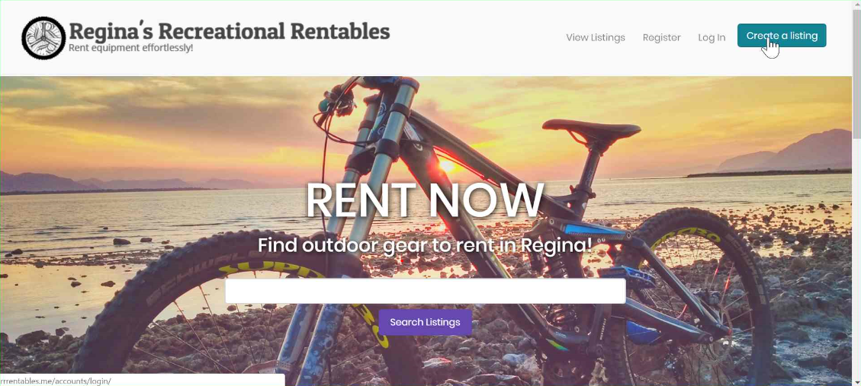

You must be logged in to create a listing. If you are not logged in, you will be prompted to enter your login credentials.
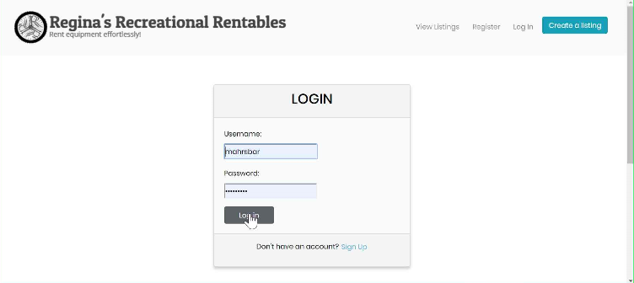

After you have successfully logged in, you will be redirected to “My Listings” page.
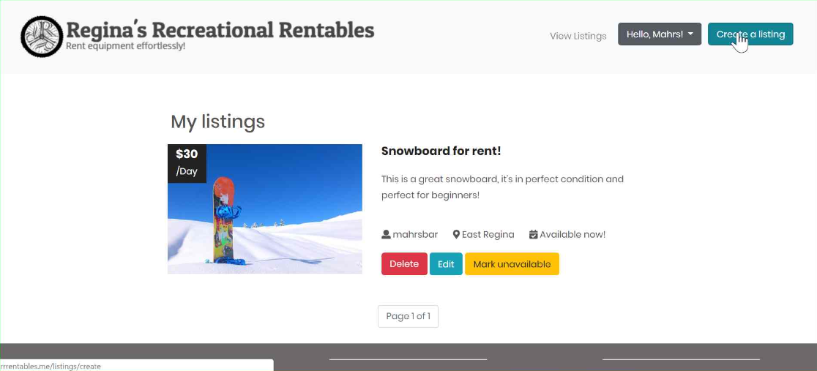

Now, when you press the “Create a listing” button, you will be directed to the Create a listing page.

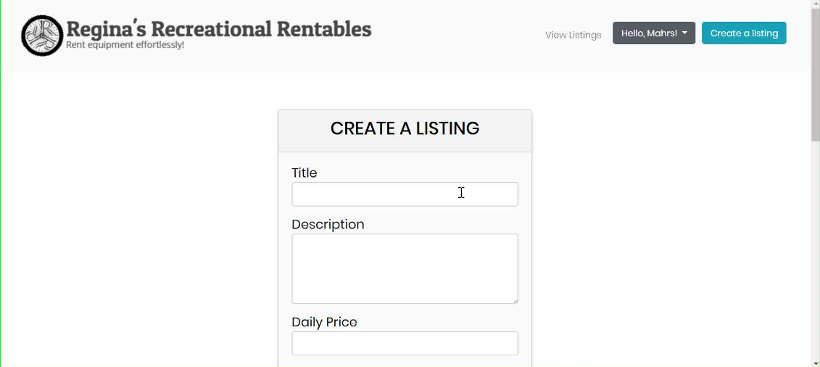

Enter the title of your listing, a few sentences describing the item, and the daily price you want to charge for renting the item.
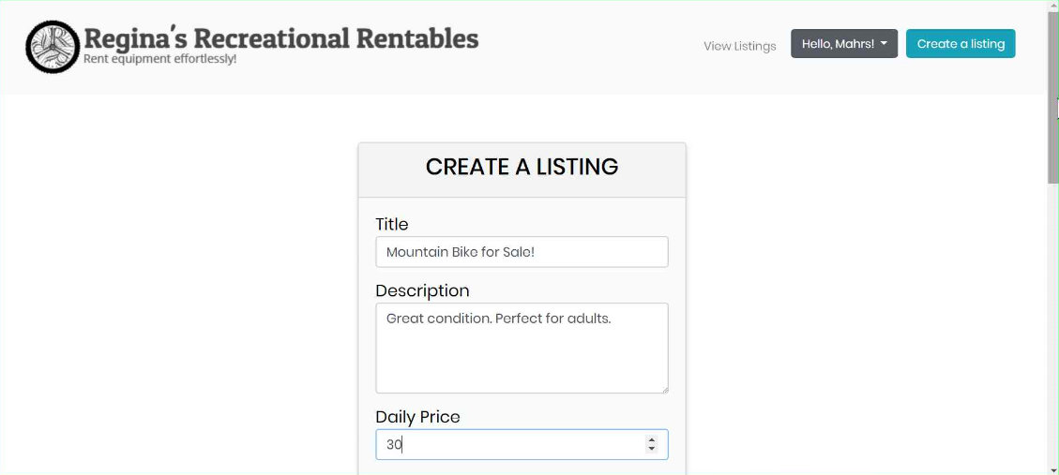

Select your location and upload photos of the item. You can select up to five photos.
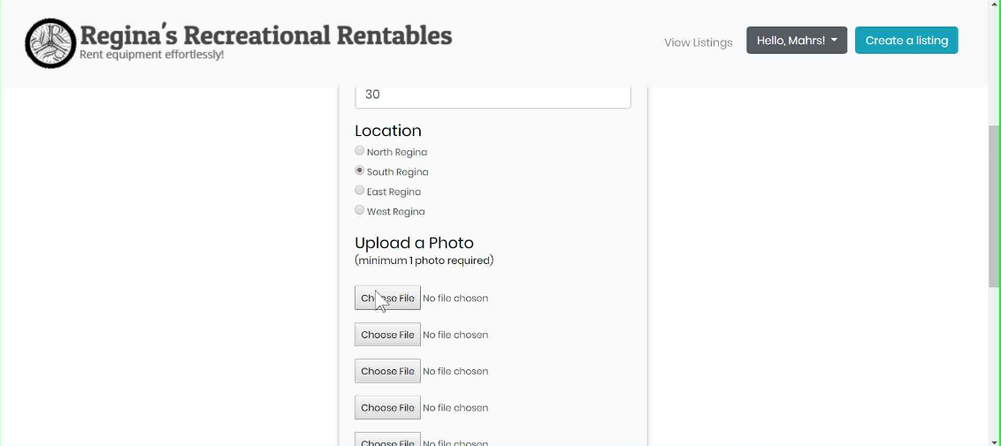

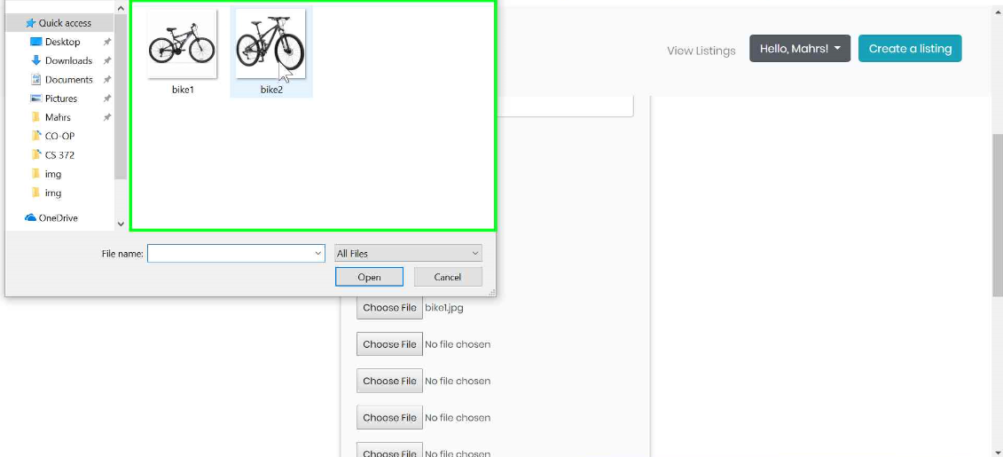
Press submit to create your listing.
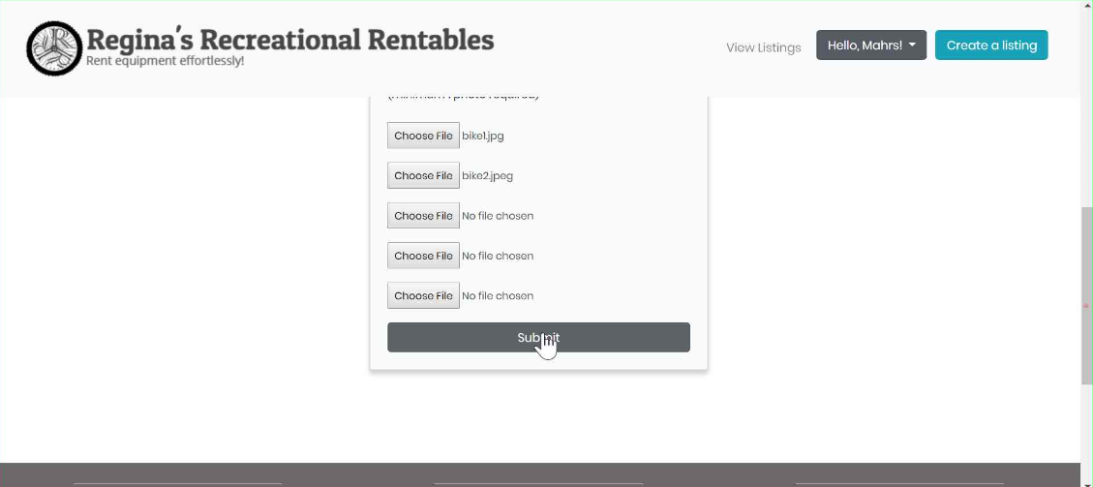

As the message claims, the listing has been successfully created. It will be available on the main listings page for others to see after the admin has approved it.
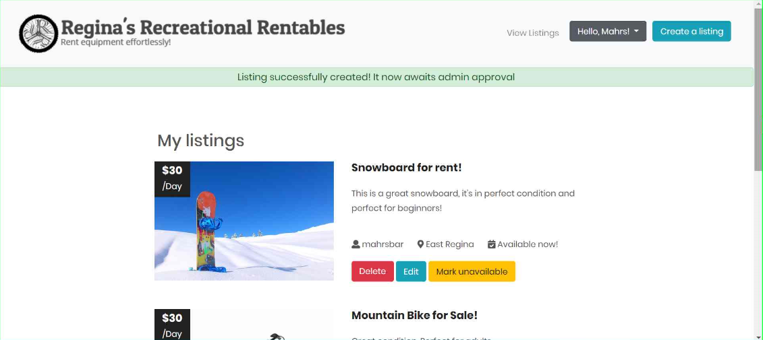

Your new listing has been created and can be accessed from “My Listings” page.
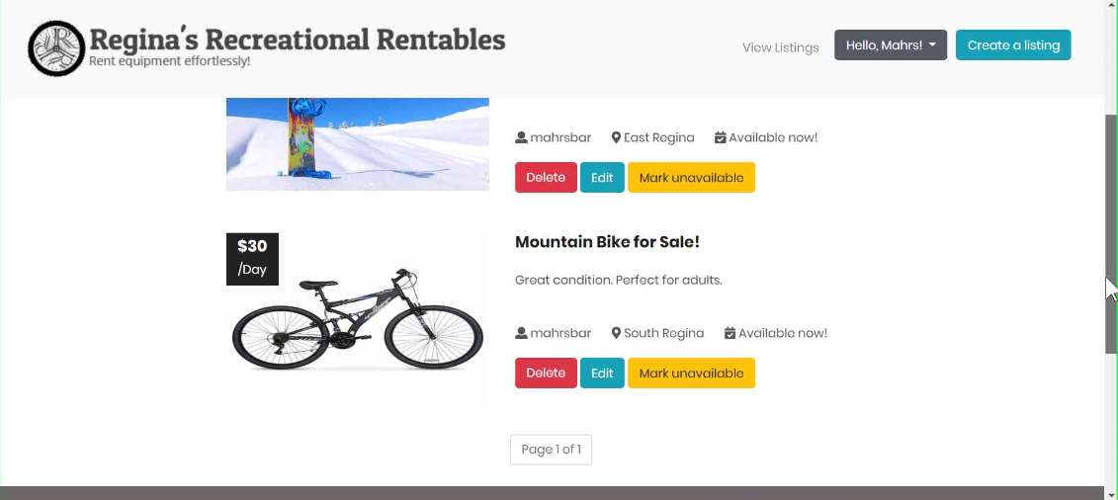

Case II: Editing a Listing
Editing a listing requires only a few simple steps!

You must be logged in to edit a listing. Click on your name in the navigation bar which will show a dropdown menu. Then, click on “My listings”
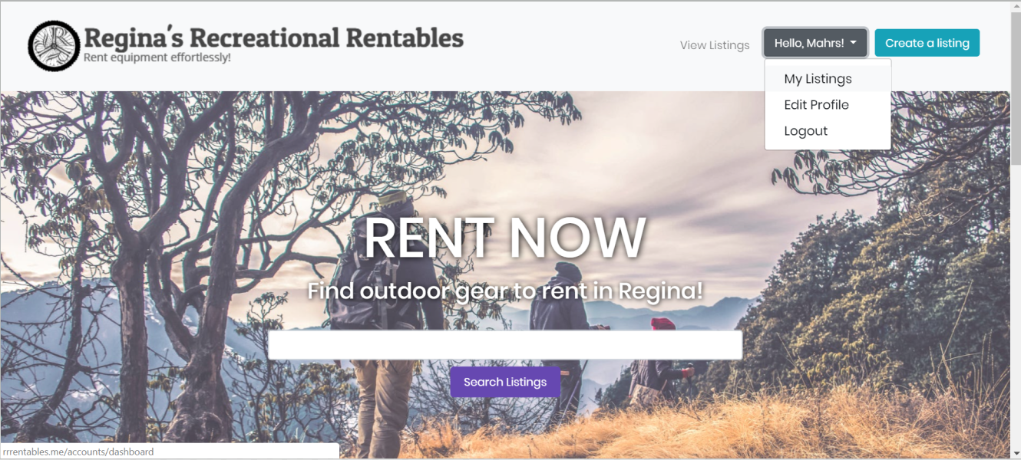

“My listings” page will display all your listings. Here, you can delete a listing, edit a listing or mark the listing as unavailable. Let’s click on “Edit”.
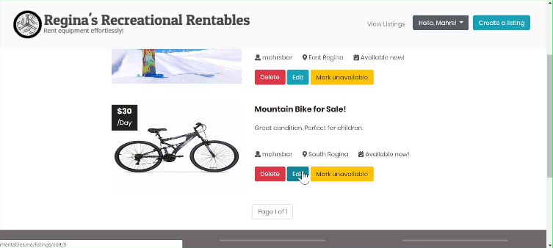

This will take you to the “Edit” page where you can edit any of the fields of your listing.
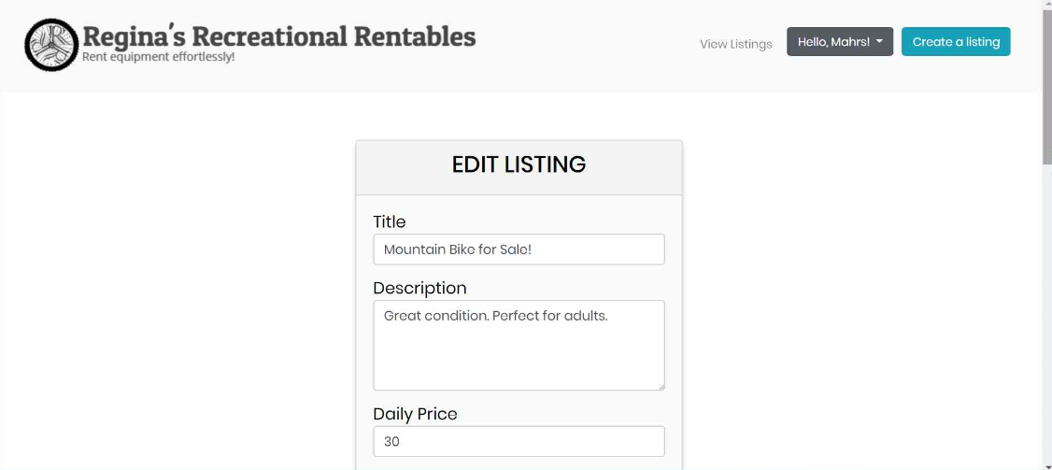

You can also upload a different image.
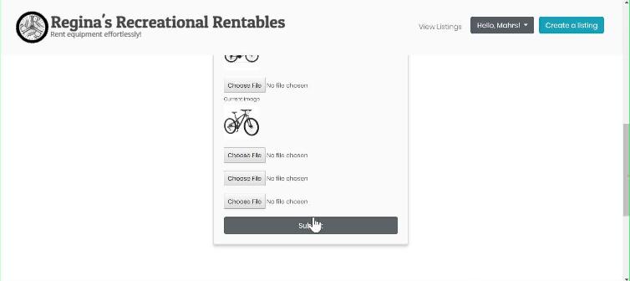

As can be observed, the listing has been successfully updated. It now has a different title, image, price and description.
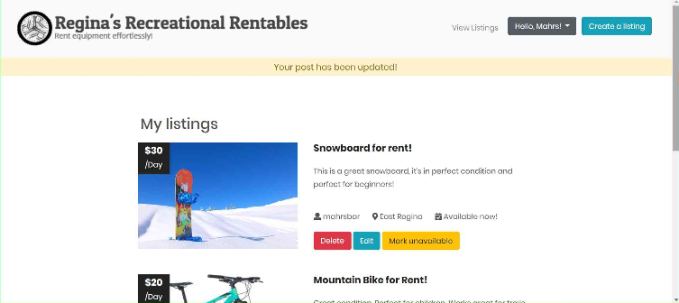

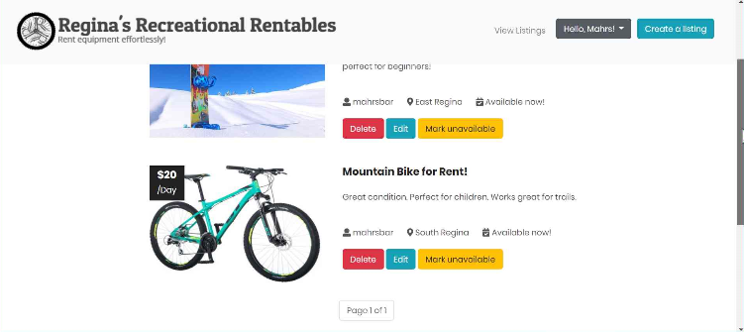
Case III: Subscribing to a Listing
Subscribing to a listing allows you to get an email notification when an item becomes available. You must be logged in to subscribe to a listing.

Click on the title of a listing to get more information about the listing.
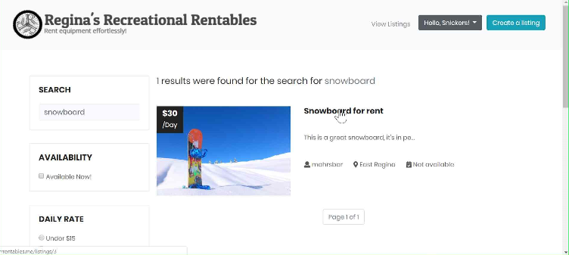

This will take you to the page that displays additional information about the specific listing. Here, you can see that the listing is not available.
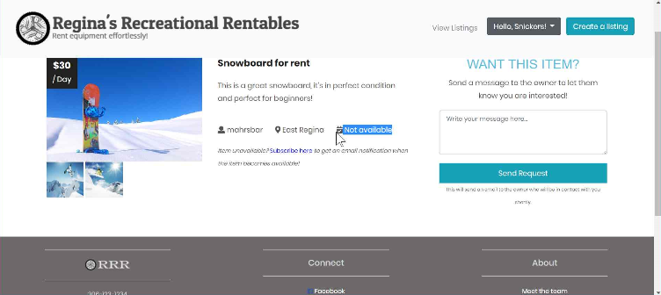
Click on “Subscribe here” to get subscribed to the listing.
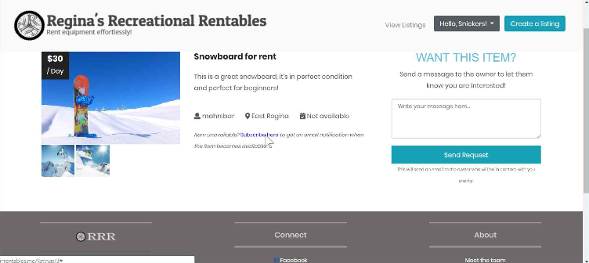

As the message states, you have been successfully subscribed to the listing.
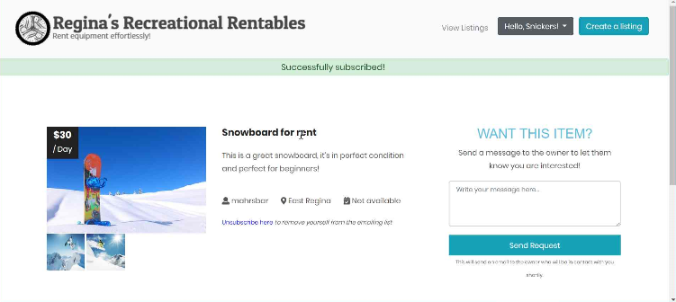

When the owner of the listing marks the listing as available, you will receive an email stating such so now you can rent the item.
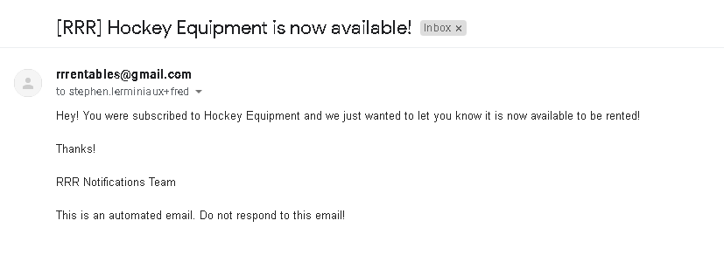
Additionally, the owner of the listing receives an email notification confirming that you were successfully notified.
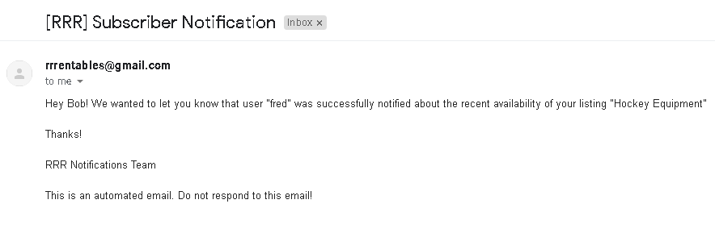

Case IV: Sending a Request Form
Sending a request form informs the owner of the listing through email that a user is interested in renting their items.

You must be logged in to send a request form.

Click on the title of a listing to get more information about the listing.
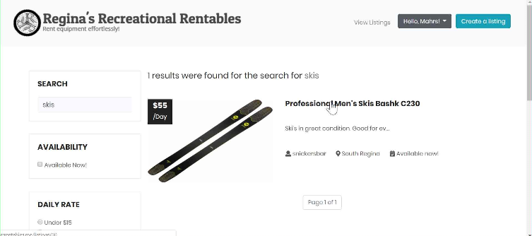

This will take you to the page with the details of the listing. Here, you can send a request form.
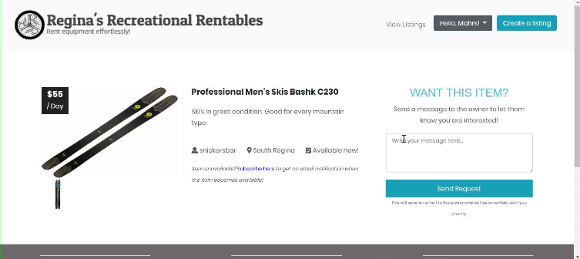

Write a message informing the owner know you are interested. Include as much information as you like.
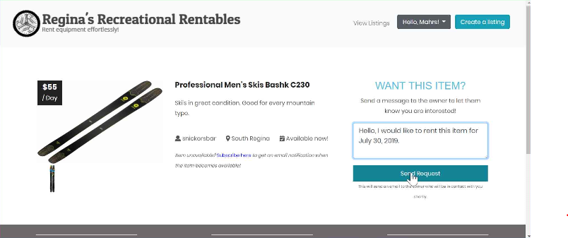

Press “Send Request” and the owner will be notified that you are interested.
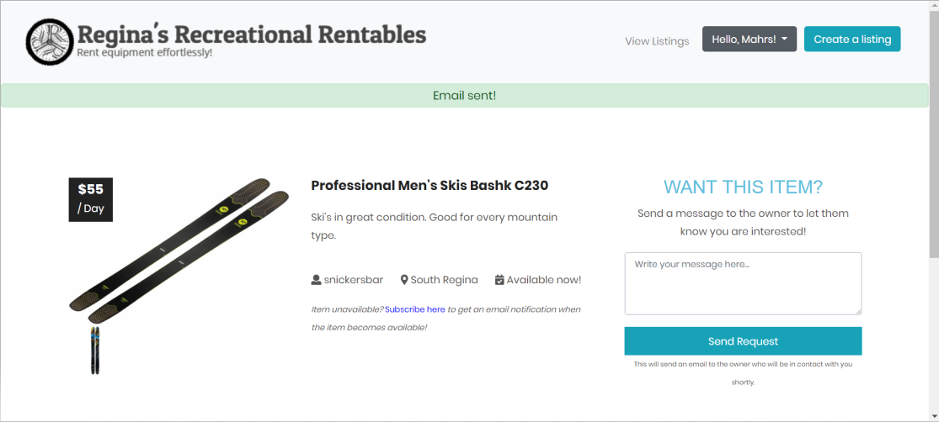

As seen below, the owner will receive your request and can contact you via your email that’s written on the bottom of the the email message.
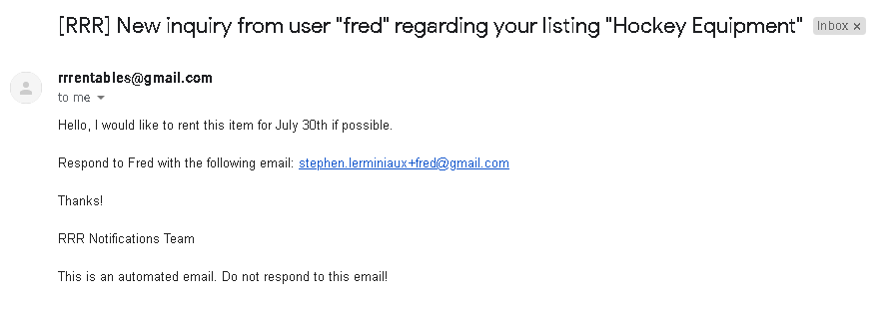

Case V: Searching and filtering for an item
Searching for an item is a very simple process. You don’t have to be logged in to search for items.

Search for the item that you would like to rent. Let’s try “bike”.
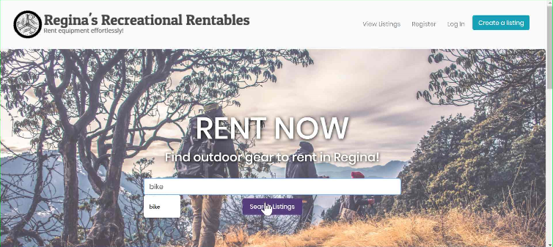

You can see that 2 results were found for bike. You can click on them to get more information and see more pictures.
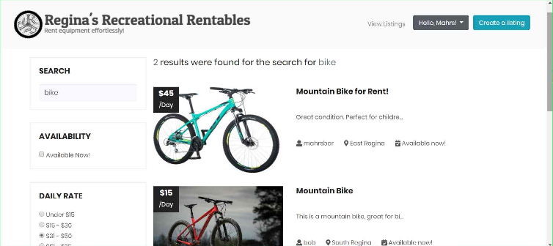

You can filter the search results by availability, daily rate and location. Let’s filter by daily rate so we only see bikes between $31 - $50. After doing so, press “Apply Filters” on the left side of the screen.

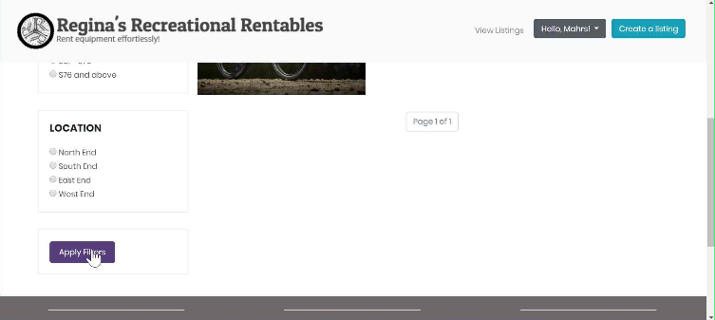
Now, the search results only show bikes that fall within the price range of $31 to $50.
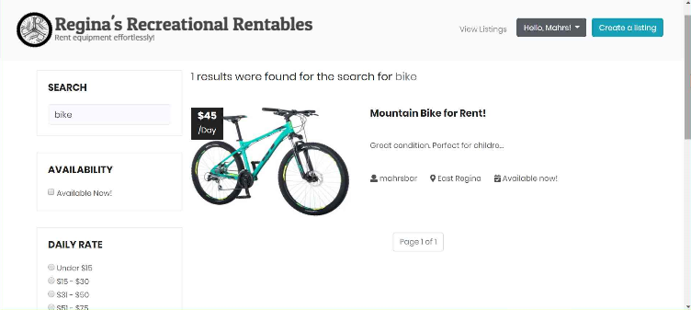

(b) Robustness testing with five incorrect input data (screenshots of inputs and outputs).
Case I: Login Validation
- Required fields are indicated
- Login prevented if necessary fields are missing/inaccurate
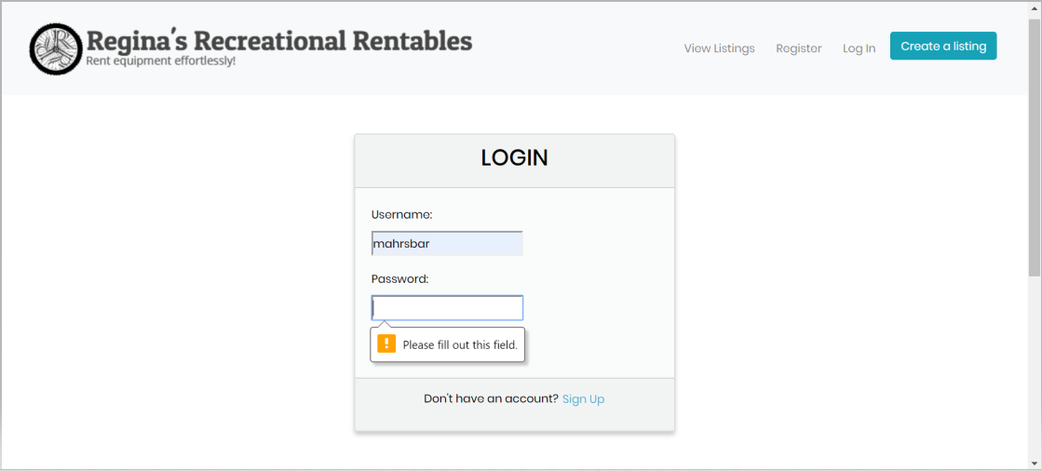

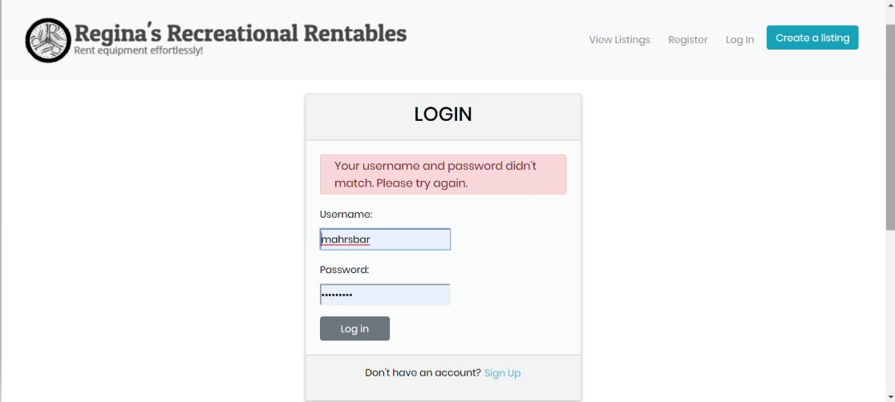

Case Il: Register Validation
Prevent users from creating an account with a username that is already in use.
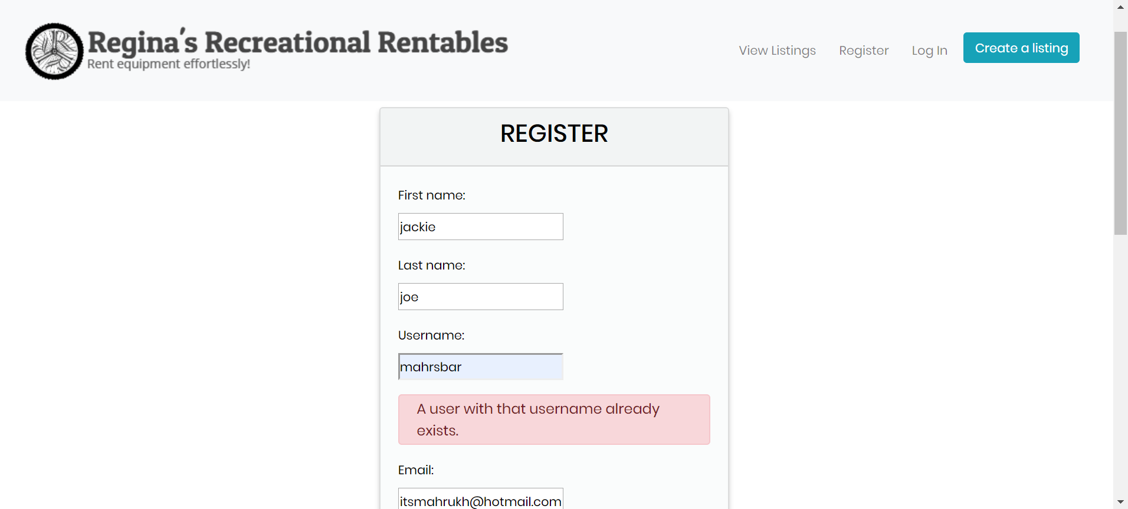

Case Ill: Post Validation
Prevent users from creating a listing with a description that is less than 15 characters.
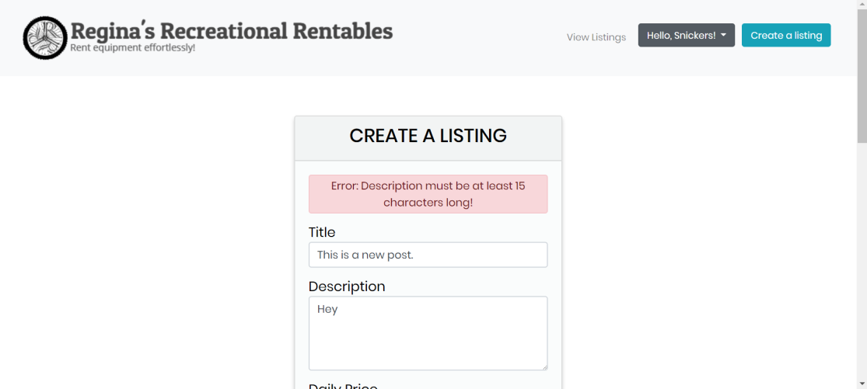

Case IV: Image upload validation
Prevent users from uploading images that do not end with .jpg, .jpeg, or .png.
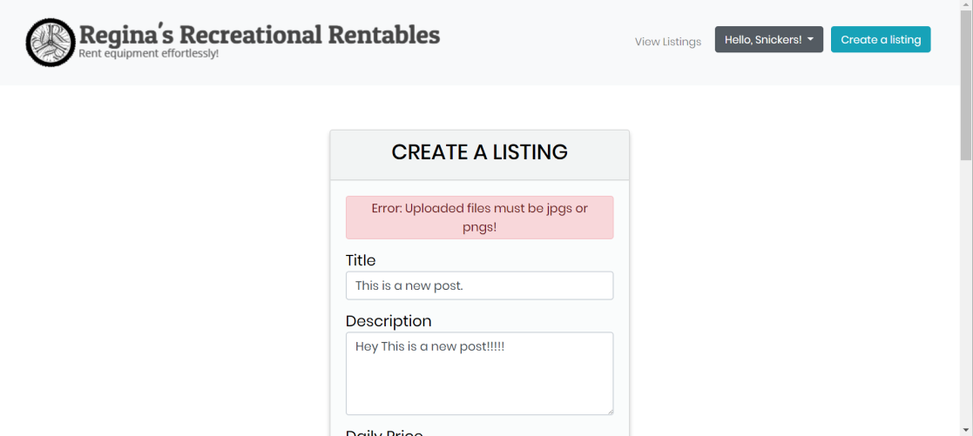

Case V: Admin Access
Prevent users without admin privileges from accessing the admin page.
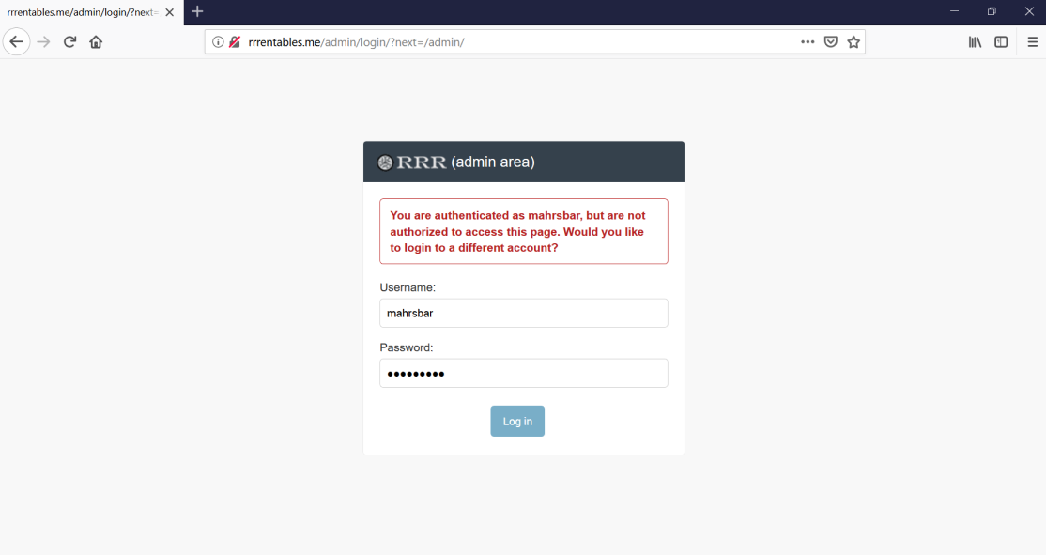

(c) Time-efficiency testing of five functions with screenshots.
Tool used: https://developers.google.com/speed/pagespeed/
Function 1: Loading search page of search query “bike”
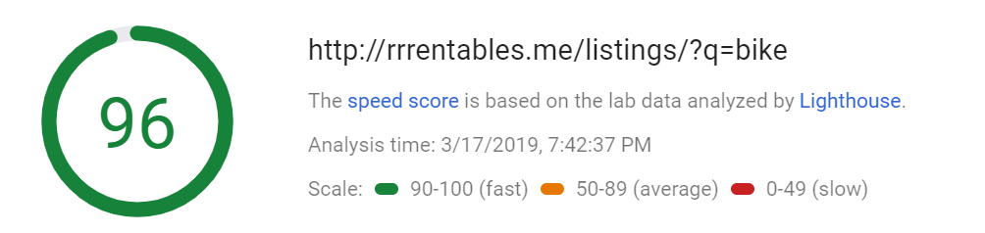
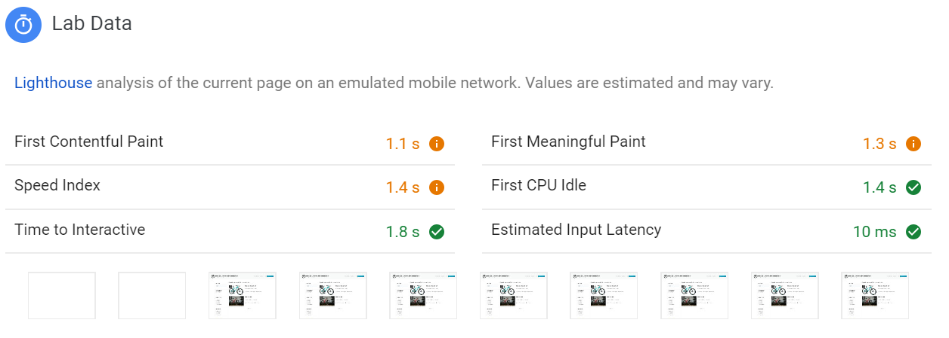
Function 2: Filtering search results with “Available now” on
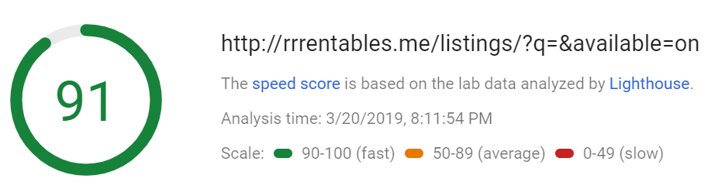
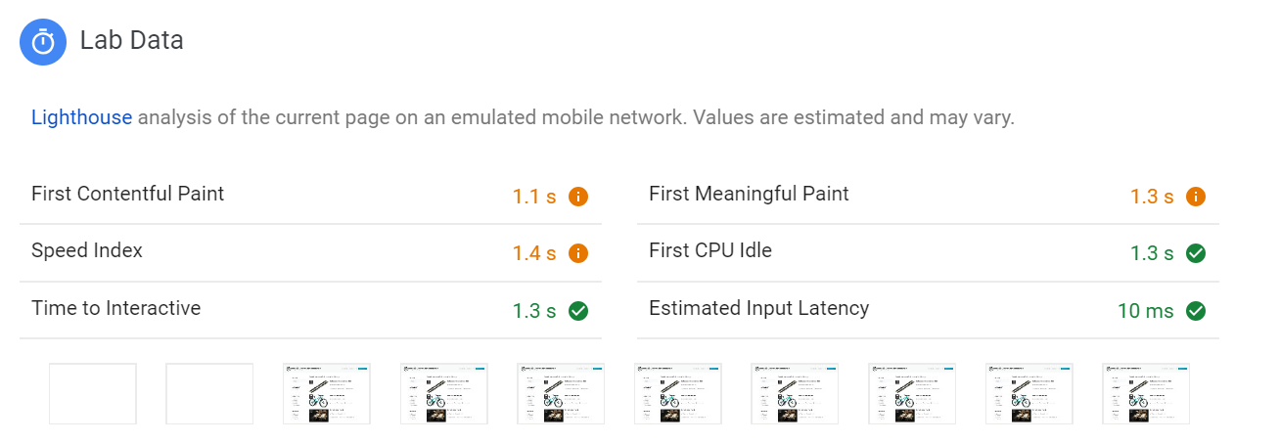

Function 3: Loading login page
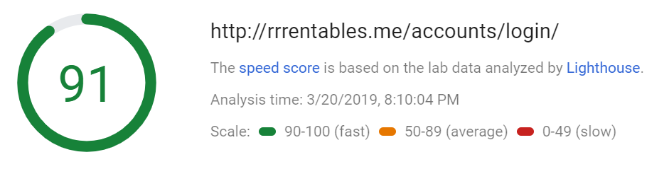
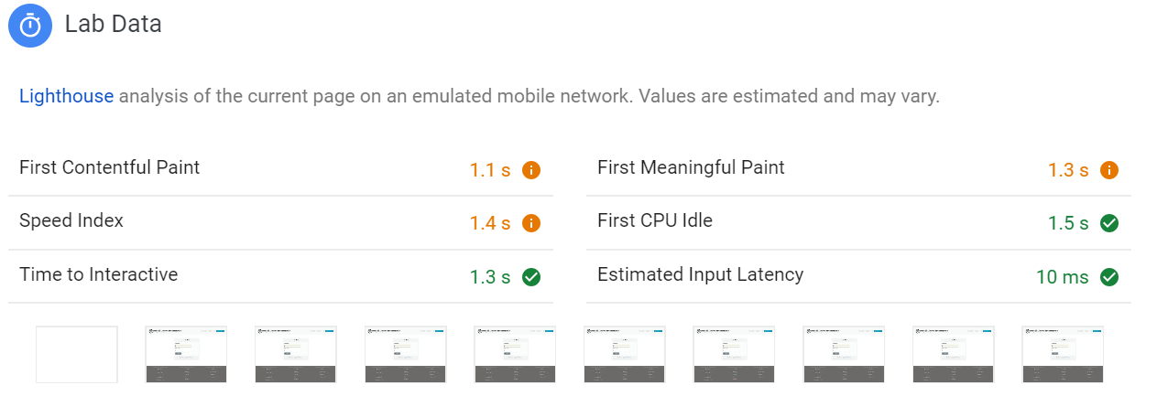

Function 4: Loading register page
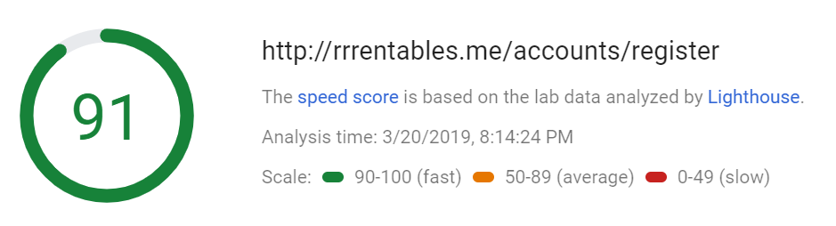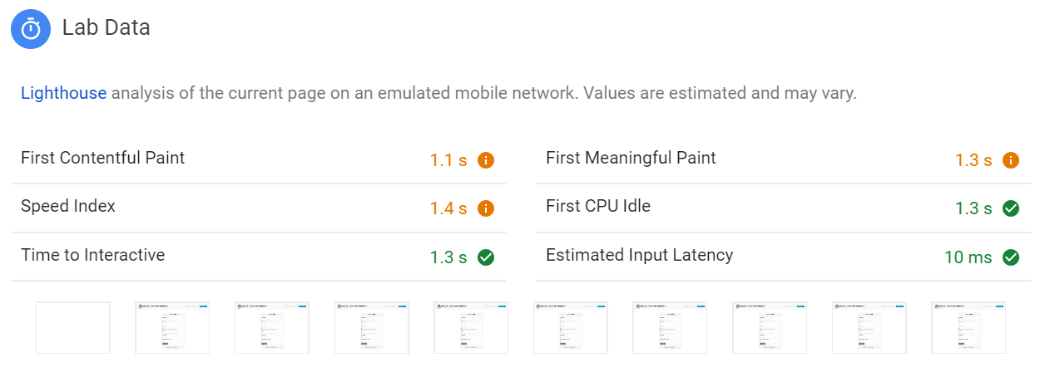

Function 5: Loading home page
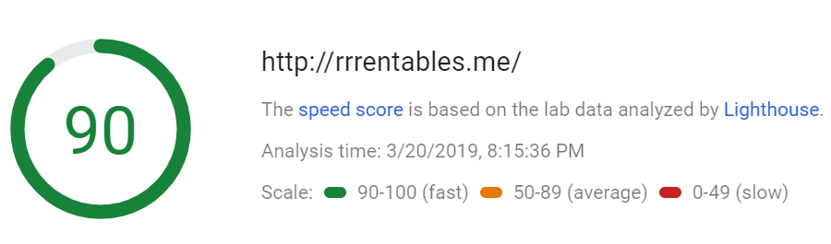
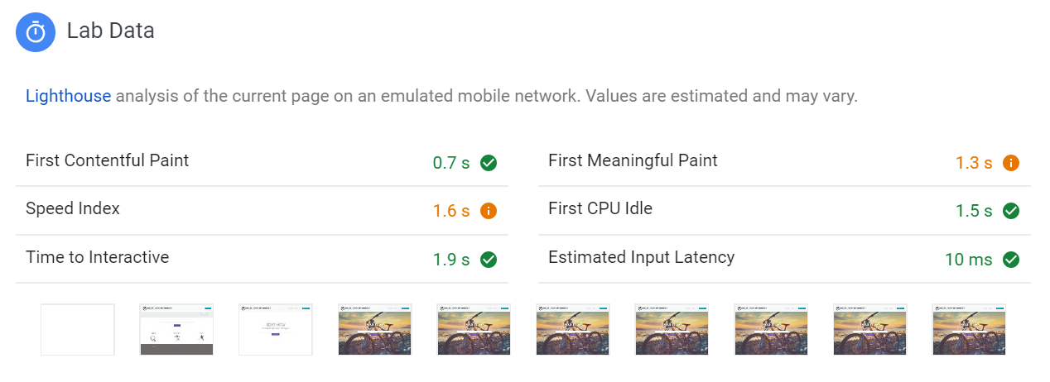

We have all contributed equally to the project.
Agreed upon by,
Mahrukh Aslam _______________________
Stephen Lerminiaux _____________________

Mathew Dorish _______________________

- What functions?
  - Search
  - Register
  - Login
  - Edit

- Tools
- https://tools.pingdom.com
- https://developers.google.com/speed/pagespeed/

User Pages:
- index.html (search)
  - Log In (also lead to register) -> login.html
    - Changes to “Hello, User”, dropdown menu
      - My listings -> viewlistings.html
      - Profile - editprofile.html
      - Logout - index.html
  - About -> about.html
  - Search item -> viewlistings.html
    - View all listings button -> viewlistings.html
  - Create New listing -> login.html -> listing.html
- viewlistings.html (search results)
  - Filter functions (dynamic)
  - Click on the name of listing -> listing.html
- listing.html (specific listing page)
  - Request function
    - Message box with submit - sends email
    - If not logged in -> login.html -> redirects back to listing
  - After requested, button becomes (Request sent!)
  - Editable content view
- register.html
  - Submit -> login.html
  - Already have an account -> login.html
- login.html
  - Submit -> index.html
  - New account -> register.html
- dashboard.html
  - All Posts (Showing name and main picture)
    - Edit listing button (user) -> listing.html with editable content
    - Delete listing button (user)
    - Set as unavailable checkbox, Hide listing checkbox
- editprofile.html
  - Save changes -> Your user account has been updated notification
- createlisting.html
  - Form
    - Title
    - Images
    - Desc
    - Price
- helpfaq.html
  - FAQ
  - Email us
- terms.html
- about.html
  - Paragraph about who we are and this project
Admin Pages:
- Approve.html
  - All listings with title and picture
    - Title clickable -> opens new tab -> listing.html
  - Approve (disappears from Approve.html, uploaded to viewlistings.html) and Reject (gets deleted) buttons with each listing, ban button beside reject
LINKS
https://uregina-my.sharepoint.com/:w:/r/personal/lerminis_uregina_ca/_layouts/15/Doc.aspx?sourcedoc=%7B9C9A57B2-2CB3-478C-8F79-35927C072FB1%7D&file=FINALREPORTDONE.docx&action=default&mobileredirect=true

